Letters

Letters are used for official business with members of the public, external organizations and between some MOD establishments. You should normally write letters on headed paper. To cater for the regular changeover of military and Civil Service staff, and the need for wide distribution, you can address letters to people using only their job title. Always use a person’s name if you are writing about a personal matter, such as welfare or administrative issues, or thank-you letters, or if the person is not associated with the MOD. Sign letters in your own right, and make sure that your job title and department or formation you represent is included. These details might be part of the letter head or part of the signature block.

If you write a letter to someone who is not part of the MOD, give your address and contact details, the recipient’s details and address and the signature block details in full. Do not include military-network phone numbers or military email addresses.

Structure of letters
- References. References are useful to both you and your reader, so fill in any spaces for ‘Our reference’ and ‘Your reference’ (even if it is just ‘Letter dated 14 January 20##’). Leaving them blank may make the reader think that you don’t see their letter as important.

- The greeting.

2.1. To a named military or Civil Service recipient. If you write to a named equal or junior who you know well, use the recipient’s forename or nickname. If you don’t know the person well, use (military) ‘Dear Rank Surname’, or (non-military) ‘Dear Ms, Mrs, Miss, or Mr …’ To greet a superior, use (military) ‘Dear Rank Surname’, or (non-military) ‘Dear Ms, Mrs, Miss, or Mr …’. For military officers, use generic ranks; for example refer to an air vice-marshal or rear admiral as ‘Air Marshal’ or ‘Admiral’ respectively.
2.2. To an unnamed military or Civil Service recipient. If you don’t know the military or Civil Service recipient’s name, address the letter to their job title and don’t use a greeting or an ending.
2.3. To a person outside the MOD. In a letter to a member of the public, use the greeting ‘Dear Mrs, Ms, Miss or Mr Surname’. When you write to a person employed outside the MOD, give their surname, their job title and the organization’s name above their address. Then use ‘Dear Mr, Mrs, Ms or Miss’ and their surname in the greeting. If you don’t know a person’s name, or want to write to an organization as a whole for some reason, use the greeting ‘Dear Sir’, ‘Dear Madam’ or ‘Dear Sir or Madam’.

3 The introduction. The introduction paragraph sets up your relationship with the reader: ‘Thank you for your letter of 10 October 20##.’ It also links what you are writing about with any previous contact with the person. Give an apology early if a mistake has been made, but first take advice on whether this could lead to legal action. If an apology is not justified but the person seems to be expecting one, try to show you understand their feelings.
- The body. In the body paragraph(s), answer the points the person has raised. It is sometimes convenient to do this in the order the person has raised them. But try to answer the main points as early as possible, otherwise a careless or busy reader may never reach them. If your reply is likely to disappoint the reader, prepare for it with words like ‘unfortunately’. Use paragraph headings in the body if the letter is very long and needs breaking up.

- The end. The end of a letter should not be a summary of the body, unless the letter is very detailed. Just use a closing statement to round off with, or highlight any action you will take, or that you want the reader to take: ‘I hope my reply has answered your questions.’ or ‘I will send the detailed information you asked for by 15 February 20##.’ or ‘Please remember to send the extra information I have asked for, so I can give you further help’.

- Review what you have written. Before you sign off, think of the answers to these questions: How would I feel if I received this reply? Does my letter answer the person’s questions? Have I explained what the next step might be? Have I been accurate, brief and clear?

- Ending and signature block. If your letter begins ‘Dear name’, end with ‘Yours sincerely’. If you begin in any other way, end with ‘Yours faithfully’. If you didn’t use a greeting, don’t use an ending. Sign the letter and add a signature block that shows your initials and surname, military rank (or title for Civil servants), and job title(unless this appears in the letter head).

Letter to a person outside the MOD example

Military Aviation Test Agency

Officer Commanding Operations Squadron Wroxbroad NORFORD NO23 7FJ


Telephone: 01777 678251Facsimile: 01777 678283 Email: ocops.sqn@mata.mod.uk Website: www.mata.mod.uk

Mrs V Pestorff Your reference: VP/CC dated 19 June 2015 Chair of Coleshurst Carnival Committee 16 Lower Street Our reference: MATA/26/1/Community Coleshurst NORFORD NO23 2YR Date: 24 June 2010

Dear Mrs Pestorff

Thank you for your letter dated 19 June 2015 and the copy of the carnival log book entries. I was sorry to hear that noise from aircraft flying from Wroxbroad Air Station disrupted the first hour of the Coleshurst carnival on 18 June. I supervise flying operations at the Military Aviation Test Agency, and work to keep disturbance from flying to the lowest reasonable level for local communities. I investigated your complaint and I can now tell you what happened.
Dr Cross, one of your carnival committee members, asked me two weeks before the carnival to arrange for locally-based aircraft to avoid flying over the site. I agreed to apply a flying restriction for the period 4.00 pm to 8.00 pm on 18 June. And I issued a temporary local order to my staff a week before the event. Unfortunately, the duty staff on 18 June did not follow the temporary order straight away. Dr Cross telephoned the air traffic control staff at 4.45 pm to complain about the noise. The call prompted the staff to put the temporary flying restrictions into force and, from 5.00 pm, none of our aircraft flew over the carnival. I have now revised some of our working practices to make sure we carry out local agreements more effectively.
You or your colleagues may find it helpful and interesting to visit the Military Aviation Test Agency to see how we work. If you would like to visit, please contact me and I will be delighted to organize the event and to host you.
Yours sincerely
I N Dung
I N Dung
Squadron Leader
¹ CC log dated 18 June 20##

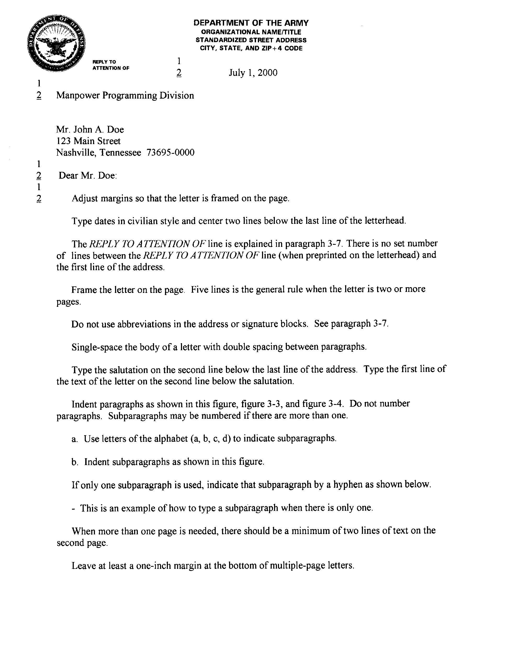
Letter to a person inside the MOD example

